**OBJECT ORIENTED CONCEPT & PROGRAMMING**

**(SE-201) LAB-5**

**TAQI HAIDER_CSIT_SECTION:B_ROLL#CT-22092**

**Exercise:-**

**Q1:-**

#include <iostream>

#include <string>

using namespace std;

class flight{

    int flight_no;

    string source;

    string destination;

    int available_seats;

public:

    flight() : flight_no(0), available_seats(0), source("empty"), destination("empty"){}

    flight(int x, int y) : flight_no(x), available_seats(y){}

    void set_data(){

        cout << "Enter Source ";

        cin >> source;

        cout << "Enter Destination ";

        cin >> destination;

        lengthCheck();}

    void reserve_seat(int seat){

        if (seat > available_seats){

            cout << "Seats not available! " << endl;

        }

        else{

            available_seats = available_seats - seat;

            cout << "Your seats are been reserved !" << endl;

        }

    }

    void cancel_reservation(int seat, char choice){

        if (choice == 'y' || choice == 'Y'){

            int temp;

            cout << "Number of seats you want to cancel: ";

            cin >> temp;

            if (temp > seat){

                cout << "Invalid Input ! " << endl;

            }

            else{

                available_seats = available_seats + temp;

                cout << "You have reserved " << seat - temp << " seats" << endl;

                cout << "Available Seats: " << available_seats << endl;

            }

        }

        else{

            cout << "Presents Seats Avilable are  " << available_seats << endl;

        }

    }

    void display(){

        cout << "Flight Number: " << getValues().first << endl;

        cout << "From: " << getStrings().first << endl;

        cout << "To: " << getStrings().second << endl;

    }

    pair<int, int> getValues() const{

        return make_pair(flight_no, available_seats);

    }

    pair<string, string> getStrings() const{

        return {source, destination};

    }

    void lengthCheck(){

        int length_source = source.length();

        int length_destination = destination.length();

        if (length_destination > 3 || length_source > 3){

            source = source.substr(0, 3);

            for (char &c : source){

                c = toupper(static_cast<unsigned char>(c));

            }

            destination = destination.substr(0, 3);

            for (char &c : destination){

                c = toupper(static_cast<unsigned char>(c));

            }

        }

    }

};

int main(){

    flight f[2];

    int flight_no[2], available_seats;

    for (int i = 0; i < 2; i++){

        cout << "Enter Details of Flight " << i + 1 << endl;

        cout << "Enter Flight Number: ";

        cin >> flight_no[i];

        cout << "Enter Number Of Seats Available ";

        cin >> available_seats;

        f[i] = flight(flight_no[i], available_seats);

        f[i].set_data();

        int seat;

        cout << "Enter Number Of Seats You Want To Reserve:  ";

        cin >> seat;

        f[i].reserve_seat(seat);

        char choice;

        cout << "Do want to modify/cancel your reservations Y/y or N/n: " << endl;

        cin >> choice;

        f[i].cancel_reservation(seat, choice);

        f[i].display();

    }

    cout << endl;

    for (int i = 0; i < 2; i++){

        if (flight_no[i] == flight_no[i + 1]){

            cout << "The Flights Are Same! " << endl;

        }

        else{

            cout << "The Flights Are Not Same! " << endl;

        }

    }

    return 0;

}

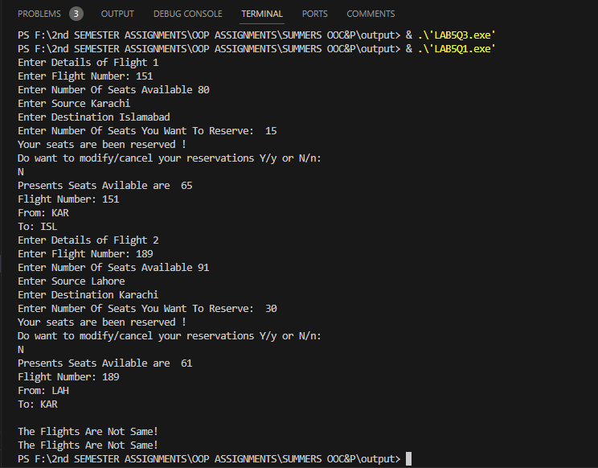

**Q2:-**

#include <iostream>

using namespace std;

class car{

private:

    string brandName;

    float price_new;

    string color;

    float odometer;

    float temp;

public:

    car(){

        cout << "Enter Brand Name: ";

        cin >> brandName;

        cout << "Enter Price When The Car Was New: ";

        cin >> price_new;

        cout << "Enter Color: ";

        cin >> color;

        cout << "Enter Current Odometer Reading: ";

        cin >> odometer;

    }

    float getPrice_afterUse(){

        temp = price_new * (1 - (odometer / 600000));

        return temp;

    }

    void updateMilage(double traveled_distance){

        double milage = traveled_distance + odometer;

        odometer = milage;

    }

    void display(){

        cout << "Brand Name: " << brandName << endl;

        cout << "New Price: " << price_new << endl;

        cout << "Price After Used: " << temp << endl;

        cout << "Odometer: " << odometer << endl;

    }

};

int main(){

    car A;

    A.getPrice_afterUse();

    cout << endl;

    A.display();

    cout << endl;

    for (int i = 0; i < 2; i++){

        double distance[2];

        cout << "Enter Distance Travelled: ";

        cin >> distance[i];

        A.updateMilage(distance[i]);

        A.getPrice_afterUse();

        A.display();

        cout << endl;

    }

    return 0;

}

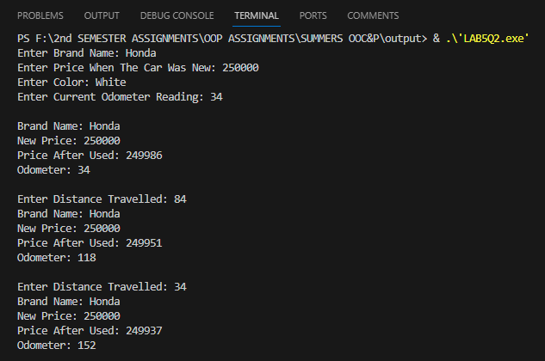

**Q3 :-**

#include <iostream>

using namespace std;

class coffee_outlet

{

private:

    int no_of_bags;

    float cost_of_order;

    int largeBoxes;

    int mediumBoxes;

    int smallBoxes;

    float const bag_price = 5.50;

    float largeB;

    float mediumB;

    float smallB;

    float total_cost;

public:

    coffee_outlet()

    {

        cout << "Enter Number Of Bags Orderd:  ";

        cin >> no_of_bags;

    }

    void costOf_order()

    {

        cost_of_order = bag_price * no_of_bags;

    }

    void no_of_boxes()

    {

        largeBoxes = no_of_bags / 20;

        mediumBoxes = (no_of_bags % 20) / 10;

        smallBoxes = ((no_of_bags % 20) % 10) / 5;

    }

    void priceForboxes()

    {

        largeB = largeBoxes * 1.80;

        mediumB = mediumBoxes * 1.00;

        smallB = smallBoxes * 0.60;

        total_cost = cost_of_order + largeB + mediumB + smallB;

    }

    void display()

    {

        cout << "The Cost Of Order: $ " << cost_of_order << endl;

        cout << endl;

        cout << "BOX Used: " << endl;

        cout << "\t" << largeBoxes << " Large"

             << "- $ " << largeB << endl;

        cout << "\t" << mediumBoxes << " Medium"

             << "- $ " << mediumB << endl;

        cout << "\t" << smallBoxes << " Small"

             << "- $ " << smallB << endl;

        cout << endl;

        cout << "Your total cost is: $  " << total_cost << endl;

    }

};

int main()

{

    coffee_outlet c1;

    c1.costOf_order();

    c1.no_of_boxes();

    c1.priceForboxes();

    c1.display();

    return 0;

}

